1. 
2. 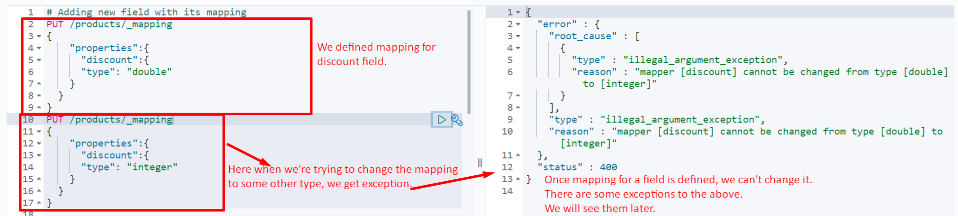
3. **Solution**: Delete the existing index, create new mappings and re-index all the documents.
4. It sounds to be very inconvenient and you would be right about that but there is a good reason why this is necessary.
   1. If we were able to change the mapping of a field, we would effectively invalidate any existing documents that had already been added to the index.  
      
5. Now we can create the index and then add the mappings.
6. We can do both with single query too.
7. 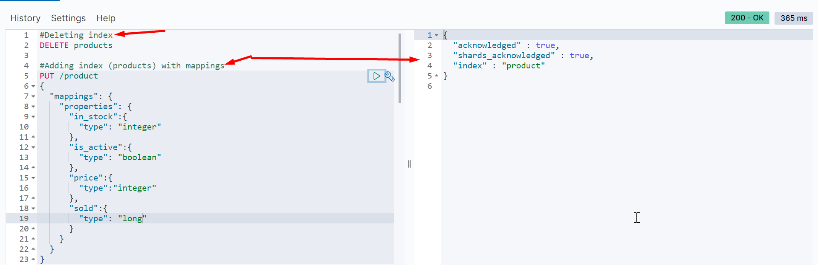
8. What I do want to mention now, is that there are a few exceptions to the rule that mappings can’t be updated.  
   You can add new properties for fields with the “object” data type, and you can also add additional mappings to existing fields. An example of that would be to add the “keyword” type to a “text” field.  
   Other than these exceptions, you will still have to delete the index and re-index its documents.